1. 参考P21例3.5仿真六种隶属函数
2. 高斯隶属函数

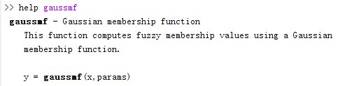

参数***ɑ***决定宽度，参数***c***确定中心

***Ɑ = 2 c = 5 Ɑ = 2 c = 9 Ɑ = 1 c = 5***

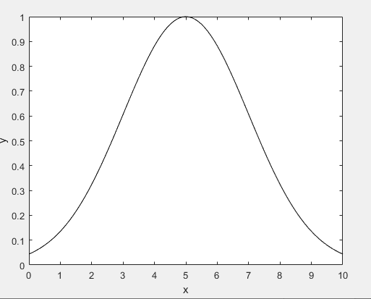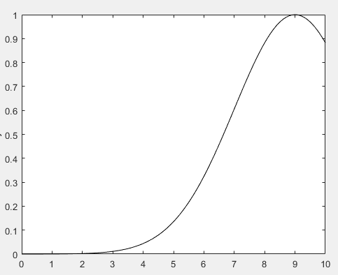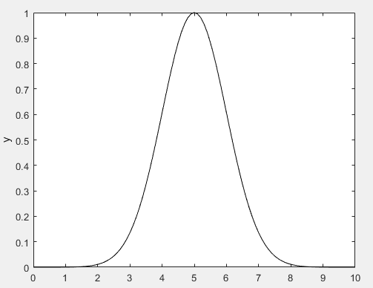

1. 广义钟形

参数a确定峰值宽度，b确定从0变化到1的变化率，参数c确定曲线中心

a = 2, b = 4, c = 6 a = 1, b = 4, c = 6

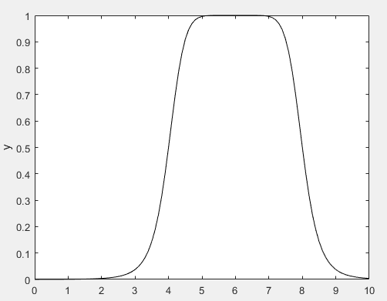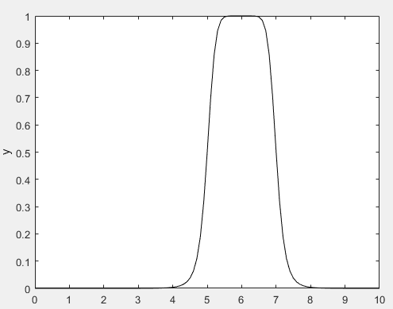

a = 2, b = 9, c = 6 a = 2, b =4, c = 1

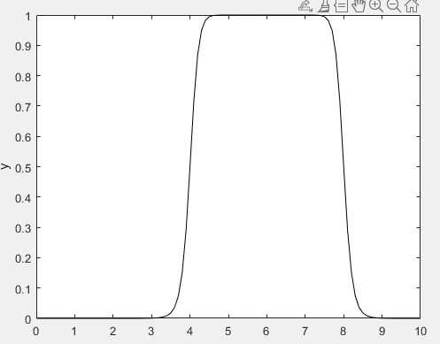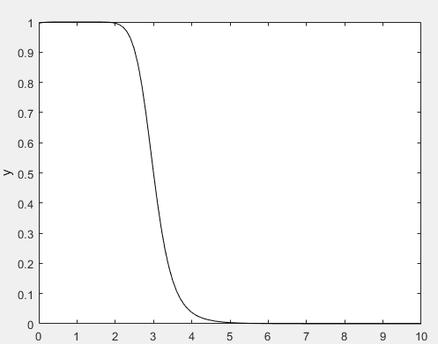

1. S形

参数a确定开口方向

A = 2, b = 4 a = -2, b = 4 a = 2, b = 8

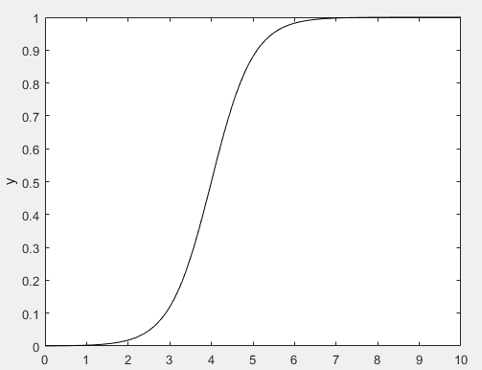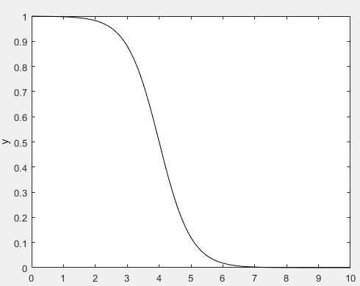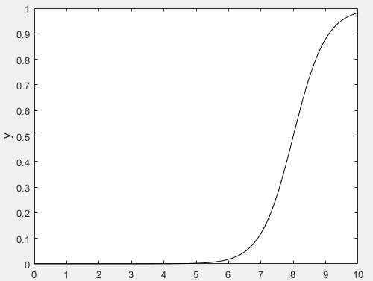

1. 梯形

参数a,d确定梯形的脚，b,c确定峰值宽度

A = 1, **b = 5, c = 7**, d = 8 A = 3, **b = 5, c = 7**, d = 9

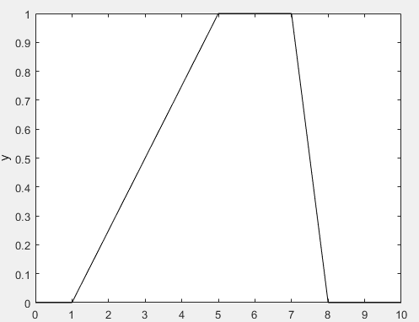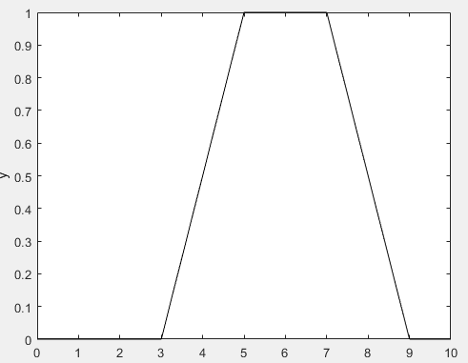

1. 三角形

参数a,c确定三角形的脚，b确定峰

A = 3, b = 6, c = 8 a = 1, b = 5, c = 9

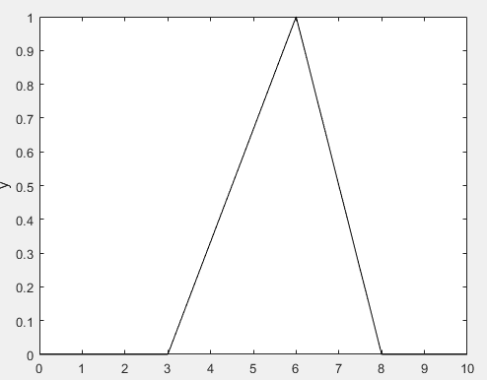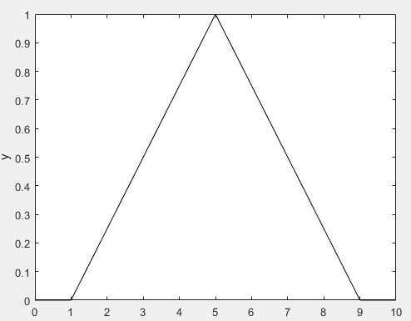

1. Z形

参数a,b确定曲线形状

A = 3, b = 7 a = 1, b = 9 a = 4, b = 6

